Synod of Victoria and Tasmania
Disability Action Plan
2023 – 2026
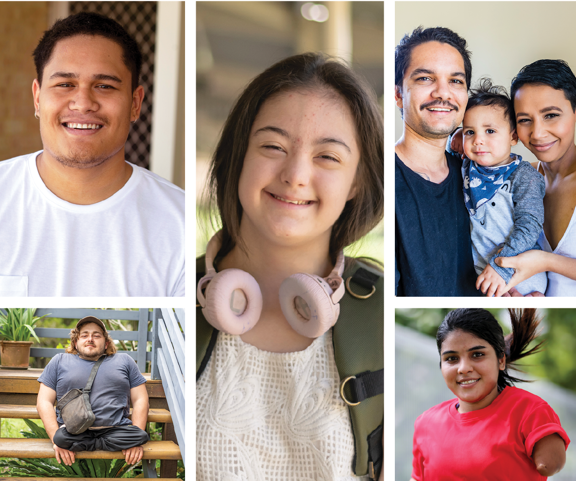
For more information, please visit www.victas.uca.org.au/ministry-mission/disability-inclusion or contact Andy Calder on 03 9340 8844 or andy.calder@victas.uca.org.au
4 March 2023
Contents
Acknowledgement 3
Assembly’s statement of access and welcome 5
Message from the coordinator of the Disability Action Plan 7
Theological background: Who is the God we worship? 9
What response is needed? 12
How Church Councils and Presbyteries can respond 12
How Synod Trusts and institutions and Schools in Association can respond 13
Matrix of Actions: 2023 – 2026 14
1. Church Councils and Presbyteries 14
2. Synod Ministries and Operations 19
3. Synod Trusts and Institutions and Schools in Association 22
Disability Resources 23
Theological and Sociological writings 23
Information about DDA, Human Rights and Website Accessibility 24
Support Organisations Resources 25
National 25
Victoria 26
Tasmania 26

Acknowledgement
We have produced this Plan in Plain Language and Easy English versions. Also the detailed supplement, How to put this plan into action can be found at: www.victas.uca.org.au/ministry-mission/disability-inclusion.
The Plan was made with feedback and advice from congregation members, staff of Synod Ministries and Operations, Trusts and Institutions and Schools in Association.
Thanks to all the people who contributed; and those who agreed to let us use their image.
For the section Theological Background - Who is the God we worship?
thank you to Rev Dr Andy Calder, Rev Dr Kylie Crabbe and Rev Assoc Prof Sean Winter.
We also thank
- Scope for Plain Language and Easy English translations
- equipping Leadership for Mission (eLM) staff for advice and guidance.
Copyright 2023
Synod of Victoria and Tasmania,
Uniting Church in Australia

Moderator's statement of support
We suddenly had to find new ways to connect and communicate during the COVID lockdowns of the last few years.
Our Church congregations and working groups found new ways of using technology.
Some people who found it difficult to go to worship or meetings could use technology to get involved.
Other people who had been involved before lockdown, found it hard to use technology to stay connected.
These examples showed us that there are different ways to welcome and include people. We can find ways to include people who find it hard to participate.
Our Disability Action Plan helps the church continue to include, welcome, listen to and be enriched by all people. This helps us be the Church we are called to be. We welcome everyone to our church as beloved ones of God. The church is where all people’s gifts can be nourished and celebrated as we all respond to God’s gracious call in Christ.
I am pleased to commend this Disability Action Plan to the Church.
Grace and peace,

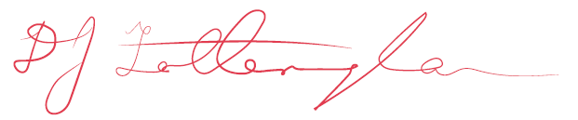
Rev David Fotheringham
Moderator

Assembly’s statement of access and welcome
In 2018, the15th Assembly talked about disability access for everything the Uniting Church does. The Assembly adopted the Statement of Access and Welcome.
The church works for reconciliation, as stated in the Uniting Church Basis of Union. The church is “a body within which the diverse gifts of its members are used for the building up of the whole, an instrument through which Christ may work, and bear witness to himself” (Paragraph 3).
The Uniting Church believes:
- Christ accepts all people unconditionally. We are called to live in the way of Christ. All people are created in the image of God, including people with disability
- The faith, gifts, hopes and dreams of people with disability are valued and honored, as for all members
- God is a God of justice and peace. God seeks reconciliation for everyone.
We want to be a community of reconciliation. The Uniting Church has not always provided this for many people with disability.
The Uniting Church wants to:
- have an accessible community for all people, through theology and practice
- make sure people with disability are treated fairly and have their hopes and rights realised
- speak up for justice and equality for people with disability in the wider community.

We have developed the 2023-2026 Plan in response to this Assembly Resolution:
To encourage each Synod to develop Disability Action Plans in accordance with the federal Disability Discrimination Act 1992, with the aim of eliminating access barriers pertaining to:
- Attitude/Theology and access and welcome
- Communication
- Physical Environment.

Message from the coordinator of the Disability Action Plan
An important part of this Disability Action Plan is hospitality, and what happens when we share a meal, or a common experience, or a journey together.
Hospitality is central for Christian communities. The writer of Hebrews reminds us that “in welcoming and entertaining strangers, we welcome angels without knowing it” (Hebrews 13:2).
Some actions in the Plan might mean we have to do our work in a different way. Some actions will mean we have to follow different laws or spend money to make changes. While we cannot avoid spending money for buildings to be more accessible, we can feel hope and energy when we see it as showing hospitality.
We can think about ways for people to access a faith community or support network, whether we do or do not know them. How do we find each other? What attitudes and values will we find? What is stopping us from being a community of hospitality? What do we need to change physically, or as a community, to be a better community of hospitality?
People with disability have told us there are three things we should work on. These needs are also explained in the Easy English version of this Plan.
People with disability want:
- to get into the place
- to feel welcome
- to have a say about involvement and contribution.
Our action plan suggests ways we can address these needs. We also ask you to think about how you can address these needs. When you think about how to address these needs, you can look at the questions in the section called What response is needed?
There is also more detail on the Disability Inclusion page www.victas.uca.org.au/ministry-mission/disability-inclusion in the part called How to put this plan into action.
We will submit this action plan to the Australian Human Rights Commission (AHRC). This shows the Synod’s commitment to finding ways to end discrimination towards people with disabilities. The Plan is also available on the Synod website: www.victas.uca.org.au/ministry-mission/disability-inclusion.
On behalf of equipping Leadership for Mission (eLM), thank you to everyone who has helped develop this plan. As we remain vigilant, we hope and pray that hospitality by the Uniting Church always finds “the stranger being entertained in our midst”.
Yours in ministry
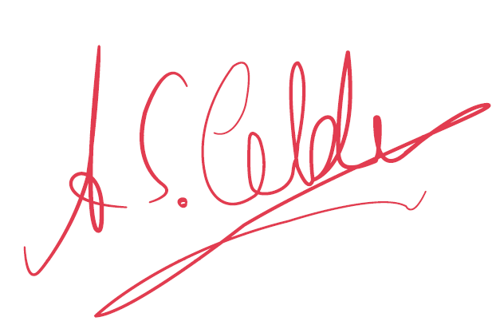
Rev (Deacon) Dr Andy Calder
Disability Inclusion Advocate

Theological background: Who is the God we worship?
“The theology of disability is central to our understanding of what it means to know who God is and to know what it means to be a human being living fully under God”. (Swinton, 2011)
This quote reminds us that it is important to think about disability the way God teaches us. We also let the experience of disability shape the ways we think and talk about God.
We are called to action when we ask the question: Who is the God we worship? This action plan helps people of the Uniting Church recognise all people as being created in the image of God (see Genesis 1:28), regardless of disability.
The church wants universal justice and equity. The Hebrew prophets were worried about justice for people on the margins of society, those who were ignored because of stigma and difference. The New Testament carried that message of justice – shown in the stories of hospitality where Jesus was either guest or host.
The prophets of the Hebrew Bible remind us of God’s concern for justice. God wants justice for people who experience oppression or suffering at the hands of others (see Isaiah 58:1–9; Amos 4:1–5; 5:21–24). People who are stigmatised because of disability are loved by God and are to be welcomed into the community (see Jeremiah 31:8; Micah 4:6–7; Zephaniah 3:19). Jesus of Nazareth also called for justice (see Luke 4:14–30) and welcome (see Luke 14:12–24). The emphasis is on God’s hospitality, offered in Jesus Christ and embodied by his followers.
While hospitality is about welcoming a person, it is also about recognising the person’s living reality. It means respecting that person’s world. We can be sensitive to their situation, without being embarrassed by it. We can be empathetic without condescending. We can be with another person without disturbing their independence.
This is a call for structural justice. Jesus and the prophets were not only worried about the plight of the poor and the widow; they also protested against religious and social structures that made life harder for vulnerable people.
As followers of Jesus, we ask: in what ways do religious and social structures support discrimination against people with disabilities? In particular, how do the structures of the church create or maintain discrimination towards people with disabilities in the life of the faith community?
Christians must question and resist cultures and attitudes that support discrimination. This is not only about better physical access to church buildings. That is a good start towards hospitality, but it is not enough. We must also look at and question the ways that the church makes policies, plans and programs. We must look at the structures and procedures of our meetings. The lived experiences of people with disabilities in our churches and society are essential for how we understand God.
Many people labelled by disability experience life outside the mainstream of society. This can lead people with disabilities to find other ways to define worth and value. As Kerrie Thorne says:
As a person with a disability, I have to define my own way. I have to work out what I value, what I’m trying to do with my life, what quality of life or hope I have. Often what I come up with may not be looked upon as worthwhile to others. It can be quite an individual thing. (Thorne, 1997)
The person with a disability stands over and against many of the norms and expectations of our culture. People with disability face a culture of achievement and find their way to achieve. We must think about how the church supports disabled people to question and resist attitudes and structures of discrimination. We can also think about the ways the church measures normality or success or achievement. Whose voice do we include and listen to?
As well as questions about disability, the church must also look at what God teaches us about able-ness. We often portray God as perfect, complete, all-knowing, all-powerful, absolutely and completely independent. With this definition, the call to “be perfect, therefore, as your heavenly Father is perfect” (see Matthew 5:48) is a call to strength, independence and self-reliance.
However, Christians believe that we can know what God is like by looking at Jesus. When we think about ideas of perfection, we need to think about the way Jesus shows us God’s perfection. In Philippians 2:6–11 we are told that Jesus does not put himself as equal with God. Instead he chooses humility to the point of suffering and death. Both the Hebrew Scriptures and the New Testament talk about God’s self-giving love (see Hosea 11:1–4; Galatians 2:20; 1 John 4:10). This kind of love defines God’s perfection. We need to re-think our understanding of suffering. It is the disabled God on the cross who suffers with and for us (Cooper, 1992). In Jesus, God is a person who:
- suffers and understands the experiences of other people
- speaks to our human experience
- offers love and hope.
From this understanding of God, Christians and the church are called into relationships with people with disabilities. We do not see people in terms of their relative able-ness (be it cognitive, sensory, physical or.....). Divine love reminds us that God sees the world in the way the person with a disability experiences it. As Jesus reminded his followers, God is present in the stranger, the poor and the hungry (see Matthew 25:31-46).
The gospel tells us that relationships with people with disability are about companionship, solidarity and cooperation as we work for justice.

References
John Swinton, “Who is the God We Worship? Theologies of Disability; Challenges and New Possibilities”. International Journal of Practical Theology, 14 (2011) p 272 – 307.
Kerri Thorne, “Outside the Mainstream”. Published in Challenging Disabled Practices: Talking about Issues of Disability, 1997 Dulwich Centre, Adelaide p 27 - 30.
Burton Cooper, “The Disabled God”. Published in Theology Today. 1992 Princeton, NJ.

What response is needed?
An action plan is what it says it is: a plan for action. In this Plan, we have a table of actions that say what we will do.
We also have some suggestions to help you take action. You can use this Plan to make your own response.
We suggest you
- read the matrix of actions
- answer the questions for your organisation go through the six steps
- compare them with the Matrix of Actions 2023-2026 section (p 14).
The Disability Discrimination Act 1992 (DDA) recommends that government, business and service providers make their own action plans. The Act aims to improve equity and access for people with disabilities. The Act aims to reduce complaints under the Australian Human Rights Commission (AHRC). We will give this Plan to the AHRC to show we are serious about equity and access. AHRC may consider the action plan when considering any complaints. If someone complains, AHRC could use the Plan to see if the adjustments needed are reasonable for us to make.
We chose to develop the action plan. The Plan gives us a chance to really address the issue of access. We can learn by the process of doing this Plan.
People with disabilities have told us they want:
- to get into the place
- to feel welcome
- to have a say about involvement and contribution.

How Church Councils and Presbyteries can respond
Has your Council or Standing Committee recently reviewed how you respond to people’s needs? Do you consult with people who will be affected by changes and improvements? Have a look at the Objectives and Strategies 1.1 to 1.3 in the Matrix of Actions section (p14–18).
Have you assessed your current practice against these? You can also look at How to put this plan into action on the Synod website:
www.victas.uca.org.au/ministry-mission/disability-inclusion
These are the steps you can take:
- Assess the current situation
- Work out solutions
- Communicate
- Set priorities and goals
- Implement
- Review and evaluate.

How Synod Trusts and institutions and Schools in Association can respond
You and your governing body or manager could review Objectives and Strategies, 2.1 - 2.10 and 3.1 in the Matrix of Actions section (p19–22).
You could also use How to put this plan into action on the Synod website:
www.victas.uca.org.au/ministry-mission/disability-inclusion
You can use these steps:
- Assess the current situation
- Work out solutions
- Communicate
- Set priorities and goals
- Implement
- Review and evaluate.

Matrix of Actions: 2023 – 2026
We have these actions to increase positive attitudes and participation and to end discrimination. This Plan will be updated after the federal Disability Royal Commission (DRC) publishes their report and recommendations.
We plan our actions around these three principles:
- to get into the place
- to feel welcome
- to have a say about involvement and contribution.

1. Church Councils and Presbyteries
Objectives | Strategies |  | Initial Task | Timeline | Performance Indicators | Responsibility
1.1 Make sure we consider disability issues in worship life, meeting planning and building planning. | 1.1.1 That worship and meetings are held in accessible venues. | A future edition of Meeting Together Booklet will include information about disability inclusion. |  | Ongoing. | People who want to attend can participate fully.  Every Church Council meeting agenda will have time to talk about access issues. | Congregational worship committees, Church Council and Standing Committee of presbytery.
 | 1.1.2 That presbytery and congregations work with Property Services before changing or building anything. | Use Synod’s Disability Access Fund (DAF) when appropriate.  Annual access and safety audits will be included in Property Services' Essential Safety Measures (ESM). |  | Ongoing. | More buildings meet accessibility requirements. | Presbytery Resourcing or Property committees, Church Council and Synod Property Services.
 | 1.1.3 Display and promote signs about accessibility on street front notice board, access doors,  web-sites and in information about Church activities. | Promote Assembly Access Guidelines to congregations and presbyteries. Make sure this works with Property Services and annual audit processes.  Promote the Disability Action Plan and the reasons for the Plan. |  | Ongoing. | More accessible buildings, and more people with disabilities using them. | Church Council.
1.2 Make sure people with disabilities can fully participate in worship, social and leadership roles. | 1.2.1 Help people believe in all people as gifted, and made in the image of God. |  |  | Ongoing. | Increasing presence and involvement of people with disabilities in worship and meeting life of UCA. | All members and UCA attendees.
 | 1.2.2 Use and promote inclusive and welcoming language in communications (disability friendly language). |  |  | Ongoing. | To enhance friendship and supportive relationships with people with disabilities and their families & carers. | Church Council and Synod’s Disability Inclusion Advocate. Synod Communications Team.
 | 1.2.3 Promote inclusive theology, images and studies. | Use of Synod Bible Studies 2021, some disability and theology resources and Assembly’s Statement of Access and Welcome. |  | Ongoing. | Increased awareness and conversation about full participation and contributions. | Church Council, ministry agents and Synod Disability Inclusion Advocate. Synod Communications Team.
 | 1.2.4 Use Synod Mental Health Kit 2019 to support people and for discussions, Bible Studies, and liturgy. |  |  | Ongoing. | Less stigma about mental health, and more acceptance of people and families living with mental illness. | Church Council and congregations.
 | 1.2.5 Organise and promote mental health supports including Mental Health First Aid Courses (MHFA) and seminars. |  |  | Start in 2023 and ongoing. | More understanding of how to support people and how to use Regional Grants to support this. | Church Council, presbytery ministers & leadership and Synod Disability Inclusion Advocate. Synod Communications Team.
 | 1.2.6 Use training and resource materials, liturgical resources, large print format, and audio loops.  Include people who know how to encourage participation of everyone. | Promote and use Assembly’s Called to be a Church for All liturgy.  Promote and use Synod’s Autism and Congregational Life resource.  Explore liturgical response and resources with people with intellectual disability.  Use more Easy English in worship and communications. |  | Ongoing. | More people with disabilities participating in the UCA in a positive way.  More people using the resources on the Disability Inclusion page. | Congregations and Synod Disability Inclusion Advocate.
 | 1.2.7 Online and screened Congregational, Presbytery and Synod resources will be captioned. | Identify and create resources for Congregation and Presbytery leaders to use for captioning. |  |  | Captioning is used in Presbytery Resourcing and Congregation live streaming. | Presbytery communication volunteers and staff. Congregation communication volunteers and staff. Synod Communications Team.
 | 1.2.8 To learn from the difficult relationship and history of disability and healing in the church. | Identify a range of theologies, practices, strengths and weaknesses of healing ministries in the church.  To identify where apology, lament or repentance may be needed for things that happened in the past. |  | Ongoing. | Make the role of healing ministries clear in the church about disability.  The church makes an apology for hurt caused in the past through healing ministry practices. | Disability Inclusion Advocate and Ministry Agents.
1.3 Tell people about Synod’s 2023-2026 Disability Action Plan (DAP). Help people to work towards universal access, and end discriminatory practices. | 1.3.1 Congregations and presbyteries will tell people about the Synod’s DAP. |  |  | 2023 and ongoing. | Make the changes that are needed, using Synod’s DAP.  Work with people with lived experience of disability. | Congregations and presbyteries. Synod Communications Team.
1.4 Do something about the Disability Royal Commission (DRC) Report and Recommendations. | 1.4.1 Use the Principles developed by Assembly’s DRC National Task Group, with the Culture of Safety Unit and other relevant parts of Synod Operations (eg Complaints processes). | Identify and develop appropriate policies and practices for Synod Operations, Culture of Safety, Presbytery and Congregational life. |  | 2023 and ongoing. | No more violence, abuse, neglect and exploitation of people with disability. | Appointed DRC Synod Task Group, Disability Inclusion Advocate and Synod Secretariat.

2. Synod Ministries and Operations
Objectives | Strategies | Timeline | Performance Indicators |  | Responsibility
2.1 Ask First Peoples to review our Disability Action Plan. | 2.1.1 Work with the First People’s Disability Network (FPDN) and Uniting Aboriginal and Islander Christian Congress (UAICC). | 2023 and ongoing. | More help as needed for indigenous people with disabilities. | Disability Inclusion Advocate and UAICC.
2.2 Make sure Synod events and activities are accessible. | 2.2.1 People use Assembly’s Guidelines for Disability Access for planning events and activities. Including Synod in Council meetings and worship events. | 2023 and ongoing. | More diversity of people participating in UCA life. | Disability Inclusion Advocate and Synod Standing Committee.
2.3 Make sure UCA properties meet access requirements. | 2.3.1 Work with Property Services to find out what changes need to be made to the way we do things. | 2023 and ongoing. | Telling everyone in all parts of UCA. | Property Services and Disability Inclusion Advocate as required.
2.4 Help congregations do Property audits. | 2.4.1 Work with Property Services to do the disability access audit as part of the annual ESM. | 2023 and ongoing. | Make renovations and upgrades according to legislation and planning requirements. | Church Councils and Property Services.
2.5 Give funding for small accessible upgrades for congregations. | 2.5.1 Make sure the Disability Access Fund (DAF) can meet current needs. | Undertake a review in 2023. | Review DAF and inform congregations and presbyteries. | Property Application Review Team (PART)/Disability Inclusion Advocate.
2.6 Make sure people with disabilities can fully participate in worship, social and leadership roles. | 2.6.1 Write a theological rationale and statement about disability inclusion, and make it relevant to all eLM ministries. | 2023 and ongoing. | Being clear about what the gospel tells us about justice and life-affirming relationships | Disability Inclusion Advocate and relevant eLM staff.
2.7 Improve communication with people with disabilities. | 2.7.1 Use Easy English and Communication Access symbols. | 2023 and ongoing. | Staff will better understand Synod Ministries and Operations, especially public or congregation-facing work.  Relevant training and work with Uniting VicTas and Uniting AgeWell. | Disability Inclusion Advocate in collaboration with relevant staff.  Synod Communications Team.
 | 2.7.2 Review web content to make sure it is accessible, via Accessibility Australia. | 2023 and ongoing. | Staff will better understand Synod Ministries and Operations, especially public or congregation-facing work.  Relevant training and work with Uniting VicTas and Uniting AgeWell. | Disability Inclusion Advocate in collaboration with relevant staff.  Synod Communications Team.
 | 2.7.3 Organise workshop with Access Consultant, with use of Disability Access Resource Unit (DARU) material. | 2023 and ongoing. | Staff will better understand Synod Ministries and Operations, especially public or congregation-facing work.  Relevant training and work with Uniting VicTas and Uniting AgeWell. | Disability Inclusion Advocate in collaboration with relevant staff.  Synod Communications Team.
2.8 Have more chances for people to understand issues of Mental Health, and to do training. | 2.8.1 Participate in Mental Health First Aid Courses (MHFA). | 2023 and ongoing. | Better awareness and knowledge. | Regional Synod staff, including camping, to participate in 2023 and beyond roll-out.
2.9 Lay and ordained students can access learning opportunities. | 2.9.1 Review current processes and find out the needs of Pilgrim College and University of Divinity. | 2023 and ongoing. | Meet the Australian Higher Education Standards. | Pilgrim Theological College and Disability Inclusion Advocate.
2.10 Make sure the Synod meets employment requirements under the DDA 1992. | 2.10.1 Make sure we have a non- discriminatory policy about employment of people with disability. | 2023 and ongoing. | Review Synod’s policies.  Have more people with disability employed by UCA. | People and Culture and Lay Consultative Committee re Staff Agreements and relevant policy.
 | 2.10.2 See if there are employment opportunity(s) for people with disability. | 2023 and ongoing. | Review Synod’s policies.  Have more people with disability employed by UCA. | People and Culture, and Disability Inclusion Advocate.

3. Synod Trusts and Institutions and Schools in Association
Objectives | Strategies | Timeline | Performance Indicators |  | Responsibility
3.1 Make sure we have policies that promote universal access, and that end discriminatory practices.  Develop policies in consultation with people with disabilities. | 3.1.1 Review and develop access and equity policies in line with Disability Discrimination Act 1992 (DDA) and other legal requirements.  Refer to the Synod 2023-2026 Disability Action Plan.  Refer to the DRC outcomes. | 2023 and ongoing. | Organisations develop relevant policies in consultation with people with disabilities, families and advocates. | Uniting Ethical Investors Limited.  Uniting Victoria and Tasmania Ltd.  Uniting AgeWell Ltd.
 | 3.1.2 Help people to develop access and equity policies in line with DDA 1992 and all relevant legal requirements, and with reference to the DRC.  Refer also to the Synod 2023-2026 Disability Action Plan. | 2023 and ongoing. | Help people to produce policies in consultation with people with disabilities, families and advocates. | UCA Schools in Association.

Disability Resources
In the past decade or two there has been more interest in disability and spirituality, in Australia and overseas.
These are some examples.

Theological and Sociological writings
Kathleen Black, A Healing Homiletic: Preaching and Disability, Abingdon Press, 1996.
Brian Brock, Wondrously Wounded: Theology, Disability, and the Body Of Christ. Baylor University Press, 2019.
Brian Brock and John Swinton, Disability in the Christian Tradition: A Reader. Grand Rapids, Michigan: W.B Eerdmans Publishing, 2012.
Andy Calder, Jayne Clapton and Trevor Parmenter, (eds.) Reflective Being, Being Reflective. 25 years of multi-faith perspectives on disability and spirituality in Australia and Aotearoa New Zealand. Synod of Victoria and Tasmania, Uniting Church in Australia, 2022.
Erik Carter, Including People with Disabilities in Faith Communities. Paul H. Brookes Publishing, Maryland, 2007.
Nancy Eiseland, The Disabled God: Toward a Liberatory Understanding of Disability, Abingdon Press, 1994.
Nancy Eiseland and Don E. Saliers, eds. Human Disability and the Service of God: Reassessing Religious Practice, Nashville: Abingdon Press, 1998.
William Gaventa, Disability and Spirituality: Recovering Wholeness. Waco: Texas, Baylor University Press, 2018.
Christopher Newell and Andy Calder, (eds.) Voices in Disability and Spirituality from the Land Down Under, New York: Haworth Press, 2004.
Tom Reynolds, Vulnerable Communion: A Theology of Disability and Hospitality. Grand Rapids: Brazos Press, 2008.
Amos Yong, The Bible, Disability and the Church: A New Vision of the People of God. Grand Rapids: W.B. Eerdmans Publishing, 2011.
Journal of Disability and Religion, Routledge, Taylor and Francis Publishing.

Information about DDA, Human Rights and Website Accessibility

Australian Human Rights Commission
www.humanrights.gov.au/our-work/disability-rights

Victorian Equal Opportunity and Human Rights Commission
www.humanrights.vic.gov.au

Office for Disability in Victoria
www.dffh.vic.gov.au/office-disability

Victorian State Disability Plan 2022-2026
www.statedisabilityplan.vic.gov.au
Tasmanian State Disability Plan 2018-2021
www.stategrowth.tas.gov.au/resources/disability_action_plan
Victorian Autism Plan
www.statedisabilityplan.vic.gov.au/victoria-autism-plan
Web Content Accessibility Guidelines
www.w3.org/WAI/standards-guidelines/wcag/

Support Organisations Resources
These organisations provide advice and information. Some organisations provide access audit services and some are NDIS providers.

National

Occupational Therapy Australia
Website: www.otaus.com.au
Phone: 1300 682 878

Independence Australia
Website: www.independenceaustralia.com/contact-us
Phone: 1300 704 456

Vision Australia
Website: www.visionaustralia.org
Phone: 1300 84 74 66

Expression Australia
Website: www.expressionaustralia.com.au/
Email: info@expression.com.au
Mobile: 0402 217 586
Phone: (03) 9473 1111

Amaze Shaping the future for Autism
Website: www.amaze.org.au/
Phone: 1300 308 699

Victoria

Noah’s Ark
Website: www.noahsarkinc.org.au
Email: hello@noahsarkinc.org.au
Phone: 1800 819 140

Scope
Website: www.scopevic.org.au
Email: contact@scopeaust.org.au
Phone: 1300 4 72673

Yooralla
Website: www.yooralla.com.au
Email: yooralla@yooralla.com.au
Phone: (03) 9666 4500

Uniting Vic.Tas
Website: https://unitingvictas.org.au/

Victorian Advocacy League for Individuals with Disability (VALiD)
Website: www.valid.org.au
Phone: (03) 9416 4003

Tasmania

Down Syndrome Tasmania
Website: https://downsyndrome.org.au
Phone: 1300 592 050
Brain Injury Association of Tasmania
Website: https://biat.org.au
Email: enquiries@biat.org.au
Phone: 1300 242 827
GROW Tasmania
Website: https://growtasmania.org.au
Phone: 1800 558 268

